MA 4780 Take Home Exam 1

Benjamin Hendrick

February 25, 2016

# Problem 1

## Part A

### (i)

The MA(2) process $Y_{t}=e_{t}+0.8e_{t−1}−0.1e_{t−2}$ can be set in R as such.

y <- ARMAacf(ma = c(-0.8,0.1), lag.max = 20)

Plot the MA(2) using the plot and abline commands.

plot(y, x = 0:20,   
 type = "h",   
 ylim = c(-1,1),   
 xlab = "k",   
 ylab = "Autocorrelation",   
 main = "Population ACF of an MA(2) model with coefficients 0.8 and -0.1")  
abline(h=0)

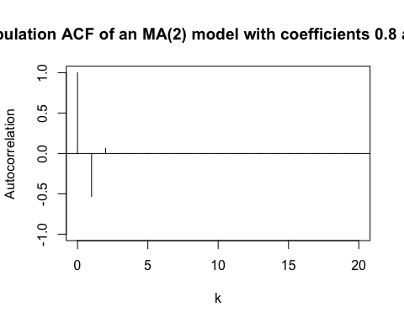

Figure shows the population ACF plot of the MA(2) process.

### (ii)

Set up the variables and sample size $n=100$ in R. Fit the MA(2) process using the lm function.

set.seed(12345)  
n <- 100  
e <- rnorm(n+1)  
y <- ts(e[3:(n+2)]+0.8*e[2:(n+1)]-0.1*e[1:n])  
fm <- lm(y~1)

Use the acf function to create the ACF plot of the sample MA(2) process.

acf(resid(fm),main ="Sample ACF plot for the MA(2) model with coefficients 0.8 and -0.1")

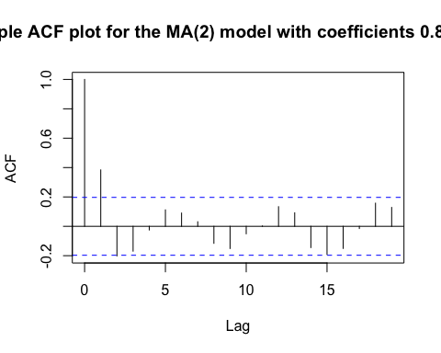

The sample ACF plot in Figure differs from the population ACF plot in Figure slightly. The population ACF plot is zero from lag 3 onward. The sample ACF plot has a sinusoidal quality to it. Both plots share the first two lags and the patterns. Lag one suggests significant negative auto-correlation.

### (iii)

set.seed(1)  
n <- 100  
e <- rnorm(n+1)  
y <- ts(e[3:(n+2)]+0.8*e[2:(n+1)]-0.1*e[1:n])  
fm <- lm(y~1)  
acf(resid(fm),main ="Sample ACF plot for the MA(2) model with coefficients 0.8 and -0.1")

